**Unitarian Universalist Church at Washington Crossing**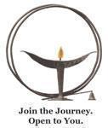

**Board of Trustees**

268 Washington Crossing-Pennington Road

Titusville, NJ 08560

**Board of Trustees Meeting Minutes - APPROVED**

**September 13, 2023**

***Multiplatform Meeting***

*President Wendy Stasolla called the Board of Trustees meeting to order at 7:02 PM. Also in attendance: Vice President, Jamie Evanini, Treasurer Denny Rodgers and Secretary Colleen McCourt; Trustees: Maria Baratta, Karen Kent, Gina Turner, Michael Waas, Michelle Zechner; Senior Minister Rev. Kim Wildszewski, Congregational Administrator, Susan Irgang and Director of Congregational Life, Robin Pugh and Ministerial Intern Lisa Schilansky.*

**First Hour**

**Consent Agenda (no vote)**

Brief discussion:

* Secretary Colleen McCourt recognized the staff’s dedicated work across numerous areas.
* Treasurer Denny Rodgers pointed out the update regarding the Northfield Bank loan (more details below under Capital Campaign/Stewardship Update).

**Capital Campaign/Stewardship Update**

President Wendy Stasolla (with support from Denny and Congregational Administrator Susan Irgang) reported that since the anticipated timeline of groundbreaking in September does not look like it will happen, the deadline for the terms of the original construction loan is expiring. Denny had a meeting at Northfield Bank with Jim Sanders and George Faulkner to discuss this. The bank representatives were cooperative and committed to working with UUCWC to renegotiate a new loan. Under a new interest rate (pending), the bank will need to reduce the loan amount by $80,000. Hopefully the third phase of fundraising will offset that. The new loan will not delay construction (independent of other factors). The bank just needs to conduct a new grounds appraisal before work is done on the building. We anticipate this will happen and the bank will issue a new agreement within 4 weeks which will need to be approved by the Board and signed. The new numbers should give us a fuller picture of where we are at with the Capital Campaign project.

Independent of the banking conversation, there is concern by the Capital Campaign team that the contractor seems to be delaying the work. They are dragging their feet and not assigning subcontractors. Farzad Shadzik, in working with the contractor, is concerned that they may be trying to get us to fire them, rather than breaking the contract on their end.

ACTION: In Farzad’s absence, Denny will contact Bob Bush and advise him to communicate to the contractor that the bank has given assurances that there is no delay from their perspective, so construction can proceed (pending the appraisal). Bob should communicate with the highest level of personnel available to avoid delay tactics by the project manager and keep momentum going forward.

ACTION: TheBoard should send thanks and affirmation to Denny, Jim and George for their efforts and dedication.

Regarding Stewardship, the committee has well-organized efforts to map out various giving efforts throughout the year, and has started planning early to optimize efforts. Their efforts will not overlap/conflict with the Capital Campaign team’s fundraising efforts. ACTION: Wendy will advise the Capital Campaign team to consult directly with Stewardship on ways to potentially tie in with an overlying theme and share messaging and vision in intentional ways.

**Survey Results**

Susan summarized the congregational survey process and results regarding the desired service time. At a high level, a majority of respondents favored continuing the 10 a.m. service time, with smaller percentages favoring earlier or later times. The Board discussed the numerical trends and anecdotal information provided, including whether attendance would be significantly impacted by a potential change to the service time. The survey results indicated overall that if the time changed, the majority of respondents would not change their attendance habits. After considering all available information via a discernment circle practice, the Board unanimously affirmed keeping the service time at 10, and communicating this to the congregation. It was also noted that we should be aware of potential misconceptions about discrepancies in travel times for NJ and PA congregants and how each group may be “prioritized,” and address them as needed.

**2nd Hour**

**Update on Concert Fundraiser - parking lot item**

It was decided to forego discussion of this item at the meeting pending further offline discussion with involved parties. ACTION: Wendy is connecting with Jim Sanders.

**Personnel Update - Onboarding of New Staff**

Rev. Kim reported that bringing on Lisa and Julie at the same time in their respective roles may bring some additional work but there is a lot of positive, intentional energy and a good fit. ACTION: Rev. Kim will send email regarding Personnel Committee changes before the Board retreat.

**Return of Welcome Table Wednesdays**

Rev. Kim referenced report on UUMA themes and the need to focus on the theme of “Among,” e.g. building connections across the larger congregation. To that end, we are bringing back Welcome Table Wednesdays, featuring dinner plus spiritual practices, to support meaningful plus lighthearted connections between and within groups and generations.

**Other Related Notes:**

* Director of Congregational Life, Robin Pughreported that she is checking in on our groups for members over 80- how they’re going and who can join.
* Trustee Maria Baratta reported that Congregational Engagement is piloting their in-person “Ask Me” table approach on select Sundays.
* Rev. Kim reported that we are pausing Faith Forward temporarily pending a meeting for all

committees to workshop their elevator speech before resuming.

**Housekeeping & Action Items**

* For October, Trustee Michelle Zechner will write the article for October about the survey results.
* We will continue to figure out a way for Board folks to equitably alternate writing CrossCurrents articles according to the ongoing publication schedule, allowing for people’s schedules and comfort level.
* We are moving toward doing multi-platform meetings every month and will try to get an idea of attendance ahead of time when we send out the agenda, including whether staff can attend to support tech needs.
* Board Liaisons: Michelle volunteered for Endowment and will contact them via email. Trustee Karen Kent volunteered for Capital Campaign and will contact them via email.

The meeting adjourned at 9:00 pm.

Respectfully Submitted,

***Colleen McCourt***

Secretary, Board of Trustees

***Jamie Evanini***

Vice President and Scribe, Board of Trustees

Executive Team Meeting-September 7, 2023

In Attendance: Wendy Stasolla, Jamie Evanini, Denny Rodgers, and Colleen McCourt

Caryl Tipton tripped and fell over the curb between the parking lot and the grass where the outdoor service was held for the pet blessing. Lynn Quinto contacted our insurance company to let them know that we had an incident on our grounds. Susan Irgang is looking into having the curb painted possibly a bright yellow to warn others of the hazard.

Erin Busch and I signed a contract with Wildflower composers to have an independent contractor compose a new piece of music to be Completed by January 2024. The words for this piece are from a poem written by Reverend Kim!

A few of us continue to be in discussions with Nick Mellis about ways to support him in his ideas for future concerts. One of our concerns is that increased use of the sanctuary will put stress on the infrastructure and disrupt the technology equipment that's used on Sundays.

Capital campaign update: Farzad and his team are concerned about the subcontractors using delay tactics because they might not want to take on our job after all. We also discovered that the loan must be re-negotiated even if we had broken ground this month. The terms were such that we would have had to go through all of our money first, before we could begin using the loan which would not have happened within that time period.

Planning for the fall board retreat is in progress and we will know by September 16th whether we will hold our meeting at Gravity Hill Farm on the 30th. It will most likely be a bring your own bag lunch whether it's at the farm or in the sanctuary.

Kim’s sermon on August 27th about past Eagle Scout projects and the current Eagle Scout project was well received in the congregation. It doesn't seem as if listening circles are necessary, perhaps just a few one-on-one conversations to help some of our members process the past and reconcile that with our decision to move forward this time.

**APPENDIX - Staff and Treasurer Reports**

**September 2023 Board Report**

**Ministers Report**

**Rev. Kim Wildszewski**

**Celebrate Life (Worship & Rights of Passage)**

Sundays in August and September have checked all the boxes! From our first Animal Blessing since 2019 (outdoors, multiplatform, requiring splitting off into two congregations, multiple forms of music, tech and more!), to revisiting the old wounds of the Boy Scouts (while also introducing our new Ministerial Intern!), to a lay-led Labor Day service, to our multiplatform Water Communion service in which we introduced three new (permanent) ritual stations – and so much more.

Please note: our admin staff (Susan and Rachel) were not “on display” at Sunday’s Water Communion, but they were essential to everything that happened. Susan returned from vacation and I needed her to be a bolt of lightning (and so she was). The worship tech team also had their work cut out for them and, while there were some blips and misses, they were - as always - exceptional in their willingness to be creative, and their execution.

Attendance has not been exceptional, but it also feels strong-enough for summer Sundays. The children’s program, on the other hand, has had solid attendance and an excellent turn out for volunteers for the upcoming year. To note: at this time last year I proposed pushing any kind of children’s programming back until October because we did not have volunteer teachers or general commitment / engagement. Before the end of August, Julie had all but one slot filled and, as of this last Sunday, has already led a teacher orientation - in which she not only included training for the volunteers but a portion on UU identity for the adults.

I have asked Julie to provide their own report in October. If you would like more regular reports from Julie, please let me know.

**Some additional notes on worship:**

The Choir performed for the first time (without a full roster) this past Sunday. They continue to grow in sound, relationship and numbers. I continue to be thrilled with what Erin is able to make possible.

Erin is also beginning her recruitment for guest musicians. We will have some returning musicians (including Megnot Toggia and the South Philly Big Band) and new talents as well.

Beginning in October in full (and almost entirely in September) every Sunday will have a spiritual practice, song and earth element that is tied to the monthly theme. Erin and I will be writing a song for the congregation to learn every month!

I have also asked Erin to provide her own report in October. Again, if you’d like more regular reports from Erin, please let me know.

**Create Community (Small Groups & Pastoral Care)**

*Creating Community will be a principal theme this year. As I’ve shared with many of you, last church year I shared with the staff three themes or intents taken from the UUMA*: Within, Beyond and Among*. We were clear that we had done* Within *well, with the growth and success of chalice circles, etc.* Beyond *was getting our Council for Faith in Action learning again (or anew) what it meant to serve and be in relationship post-Covid. We knew that last year we would not be able to meet the needs for* Among *and that this would be the focus of 2023-24.*

*And. Covid numbers are rising. The building will be under construction this year. The Pew reports that as many people will continue to choose online participation as in person going forward. This* Among *effort will require new and creative ways of doing church and community (or communities).*

At the end of August, I facilitated a Writing Your Own Memorial Service class, in which 10 women of different ages and stages reflected together on:

their families of origin, first experiences with death and funerals, given assumptions and expectations around end-of-life ritual, who memorials are for (not the dead), and what it means to articulate wishes but release the living from following through on those requests.

This was a powerful time of individual self-reflection and group connection. I hope to offer this again in the late winter or early spring.

Lectio Divina begins again this Thursday at 2pm on zoom. You (yes you!) are invited to take 30 minutes out of your day to join me for a poem and time of reflection.

Pastoral Care is significant right now – as it always is during times of transition in the church and school year. Mental Health, addiction, memory loss, aging, physical frailty, diagnoses of all kinds, and deaths are weighing heavily on many of us.

In addition, concerns of connection and disconnection are in every pocket of the congregation. Some long-term members have relayed they don’t know the new members; they want connection with them. Many newer members relay that the church centers the long-term leaders and personalities; they don’t know how to get the intimacy of relationship they see in the oldest generation.

We want to be connected and known ---- this will be the major (and explicit) intent of the staff team this year.

**Change the World**

At the end of August, we welcomed Lisa Schilansky as our two-year, part time Ministerial Intern. As always, onboarding a new staff person takes time and intention. Lisa’s curiosity and focus are making this a lighter and more joyful load. She is taking connecting and learning seriously and, upon my request, has provided her own report this month; a reflection on what she’s noticed and wonders about as someone new to our community and systems. Please take time to reach out to Lisa, welcome her, and share your thoughts about UUCWC.

I am working to change the system, dynamics and function of the Personnel Committee. A separate (executive session) addendum will speak more fully to this.

Susan Irgang and I met with the Stewardship co-leaders in August. Already Jane Root & Scott Blaydon have a month-by-month checklist that is helping forge a new way to engage giving. They will be joining me at the October Worship Associate meeting to help train our newest WAs in how to talk about giving, stewardship and supporting the church from the pulpit.

Because the staff team is entirely part time, except for me, the working schedules of staff meetings, worship meetings, one-on-ones, my personal weekly schedule, and more have had to be entirely reworked. It must be noted that I have spent a huge amount of time in the last month finding ways for the staff to connect. We are moving from bi-weekly staff meetings to one staff meeting every other month. Creating a service like Water Communion, or looking ahead to programs like Welcome Table Wednesday where so many different participants and logistical pieces are at play together, pushes me into many repetitive conversations – which ultimately takes time and creates a vulnerability in the solidity of what we can produce. We will adjust. But we are currently in the work of adjusting.

Submitted with care and appreciation,

Rev. Kim

**Susan Irgang**   
Administrator BOT Report for September 2023

**Create Community**   
I took a much-needed vacation for two weeks in August (the first full week break since last year at this time). My report therefore reflects both less weeks in the month as well as my reduced hours of 30 per week.

I jumped back in from vacation, joining the staff team with Water Communion preparations and creation of ritual stations, and oversaw the many furniture moves and adjustments that are needed to create classrooms for children’s faith engagement in upper level spaces. Two lower level classrooms will be used for storage of furniture during construction, saving the cost of renting storage space. These physical and logistical changes could not have happened without the help of Rachel Hansen and Roberto Santiago. We continue to envision new and flexible ways to use the spaces that will remain available throughout construction.

I worked on improvements in Memorial Garden recordkeeping, updating the electronic database and creating an electronic grid map of the memorial garden sites. This has already proved helpful in providing a member via email a visual “map” of where their site is for use by their family, who live at a distance.

I worked with the Communications Team to establish guidelines for submission of CrossCurrents articles regarding length of articles, submissions to include all hyperlinks and jpeg files, and other editing details. We hope to make the newsletter more readable, and will take a similar look at the weekly announcements in coming months.

I worked with Lynne Quinto to determine the best method of handling stipend payments for new ministerial intern Lisa Schilansky. I am looking forward to meeting with Lisa this week to review administrative aspects of her time with us.   
 **Celebrate Life**   
Our current membership is 276 Church Members, 25 Friends (who pledge), 23 Participants and 26 Attendees. This does not include children; we will have better numbers for our children and youth after registration for faith development ends.

When we think about our members and our church’s history, it should be noted that 20% of our membership joined from November 2019 (fall before the pandemic and just prior to Rev. Kim’s sabbatical) to present. These members do not have much pre-pandemic experience of church compared to longer term members (consider this when reviewing Worship Time Survey results later in this report). By comparison, 30% or our membership has been here 20 years or more, and 50% have been here for 4-19 years. Another statistic: 46% of current members have joined since Rev. Kim became minister.

**Change the (UUCWC) World**   
I continue to support the work of the Stewardship Team, as noted in Rev. Kim’s report. I am excited to see the fresh perspective, comprehensive viewpoint and emerging plans that new co-leasers Scott Blaydon and Jane Root have shared. Planning has already begun, the earliest in many years.

A Worship Service Start Time Survey was deployed mid August offering the community an opportunity to pick all of the service times they might prefer from a choice of 9:45, 10, 10:15 and 10:30am. We received 132 responses with 189 answers across the categories as follows:

9:45am: 31 responses or 16%  
10:00am: 84 responses or 44%  
10:15am: 22 responses or 12%  
10:30am: 52 responses or 28%

The remaining questions involved current attendance and projected attendance if the 10am start changed. Below are the results. Staff will review Individual comments.

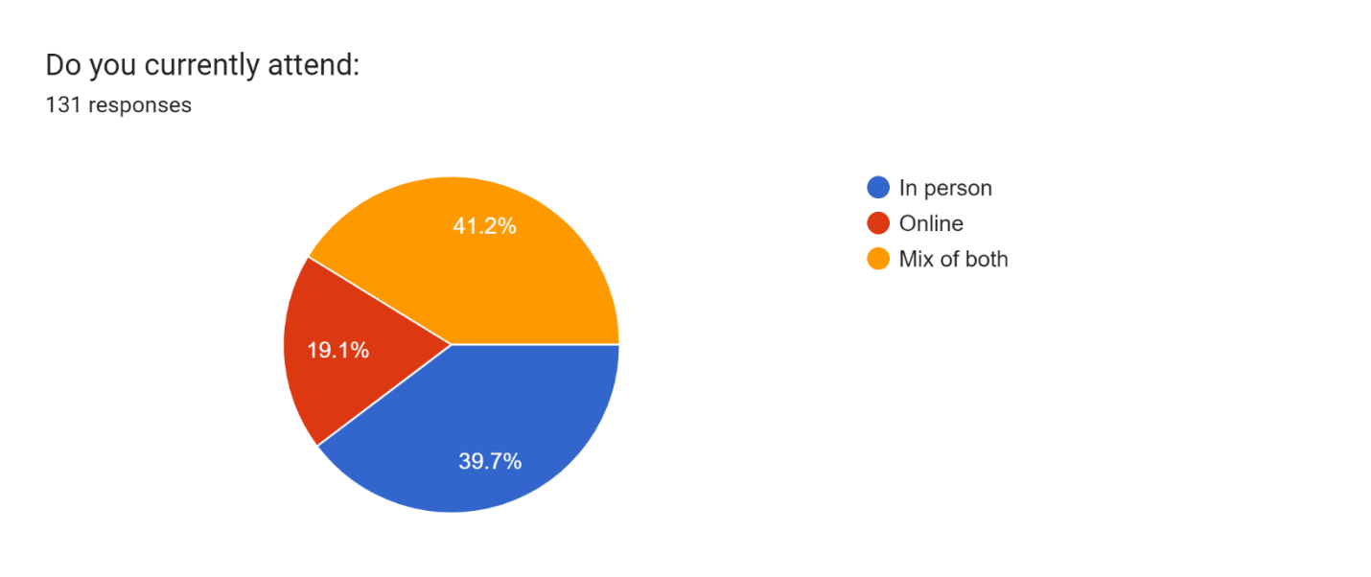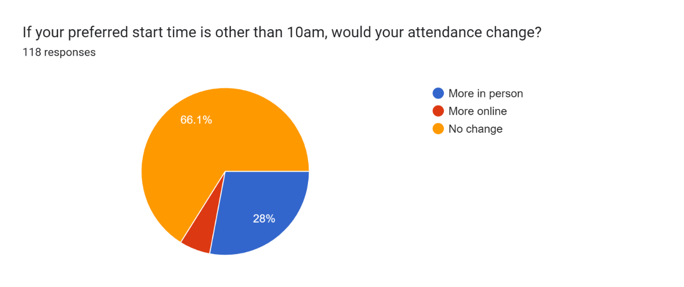

To: UUCWC Board and Kim Wildszewski

From: Robin Pugh

Date: Sept. 12, 2022

Re: Monthly DCL Report ___________________________

**Celebrate Life (Worship and Rites of Passage)**

* In August, I was on vacation for a week and on Study leave for 3 days. My report therefore reflects both my time away from UUCWC as well as my reduced hours of 20 per week.
* I worked with the entire staff team on the ingathering Water Ceremony. We are a gifted staff team and when we can all use our talents together it shows. Lisa and I led our online folks in a ritual blessing (beautiful, written by Kim) while the in-person congregation engaged in the water ritual.
* I am offering a host training on 10/1 which will cover safety and welcoming tips I learned at GA in June. I will connect with our Sunday hosts and remind them that they are “working” when their friends arrive.

**Create Community (Small Groups)**.

* We are starting a UU Wellspring sources class on Sunday. We have 9 participants (5 of them new members and participants) and 2 facilitators. The participants overwhelmingly wanted to meet in person. Kim and I are considering the different experiences of in person vs online attendance generally at UUCWC. We will continue to plan events that bring people into the building (there is a deeper connection experience when in person) as well as continuing our multi platform presence. Wellspring takes a lot of time to start up (recruiting, training and scheduling participants and facilitators) The effort pays off in growing committed UU’s and supporting the spiritual growth of our folks.
* Our 11 regular chalice circles restart this month. As always in August, I encouraged new people to join, checked in on people leaving groups and trained new facilitators.
* As Kim mentioned in her report, we are noticing concerns of connection and disconnection in every pocket of the congregation. We plan to offer Welcome Table Wednesday about once a month this year beginning on October 18th.
* Kim will offer our Pathways to membership class. In October and November. I end personal invites to all our visitors.

*This primarily serves as an FYI about my professional development opportunities that benefit my leadership at UUCWC*.

I attend the UUAMP, (the Association of Membership Professionals) weekly meetings when time permits. I see a Spiritual Director monthly.

