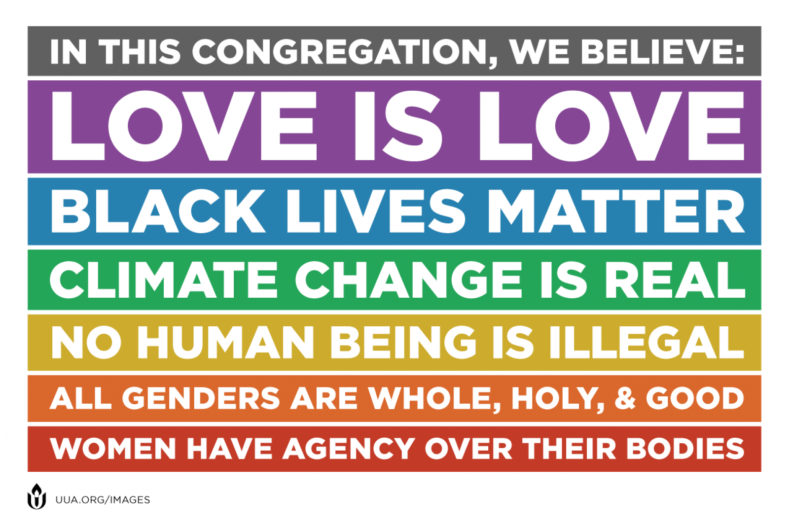

**ALL GENDERS & ABILITIES ARE   
WHOLE, HOLY & GOOD**